Valuing Investments in Extensions to Product Lines and Service Offerings
When Facing Competitive Entry
L. G. Chorn and A. Sharma DRAFT 06/30/01
Real Options Software
Dallas, TX USA

ABSTRACT
Investments in R&D for product application extensions and in infrastructure service enhancements have interesting similarities and can be analyzed in a common template. They typically require multiyear investments in outcomes exposed to several sources of uncertainty. Technical risks, market size and acceptance, and actual capital requirements make these investments difficult, if not impossible, to evaluate with a static discounted cash flow analysis. Further complicating the initial investment decision, as well as the timing of intermediate investments, is the potential for a competitor’s entry that takes market share or even eliminates demand for the product or service.

This article describes a Real Options analysis of shared options on extensions and enhancements in the energy service industry. We illustrate the analysis framework, the data requirements and the insight gained from Real Options. The material focuses on extracting managerial insight from a Real Options assessment of incremental investment programs, whose timing and success may be impacted by external market forces.

INTRODUCTION
Perhaps the most common concern expressed by management considering an investment in a foundation technology is the concern that the anticipated follow-on product or service offerings may never materialize. Investments in the foundation technology may be marginal leaving all of the upside potential in the follow-on product revenue profile. Static DCF cannot adequately capture management’s response to private risks.

Further compounding management’s concern is the competitive landscape. An obvious danger to the success of a product based on technology still in development is the effect of competitive entry. A substitute or better product may be introduced at any time, taking a portion of the target market and perhaps eliminating the potential for a favorable investment outcome. As a consequence many foundation technologies are not funded when uncertainties cannot be adequately managed.

We simplify this initial foray into valuing foundation technologies by considering only the effect of extending the capability of an existing technology into a new application area. Management must decide whether to fund the extension based on the market assessment for the application and the guidance of project experts in the capabilities of the advanced technology.

The analysis presented incorporates two interesting Real Options adaptations. In computing the volatility of the revenue profile, we consider both the effect of uncertainty resolution around today’s perception of the initial market size and the potential for a jump in the market size through technology enhancements. The impact of competitive entry on value and the management decision process is examined using the approach presented by Trigeorgis.

Mimicking Investment Behavior. Flexibility in investment behavior is the existence of options to adjust the timing and size of the investment profile as new knowledge becomes available. Economists agree that flexibility has value, but it is difficult to quantify it in a manner that can guide management action. A remedy is to identify and value the outcome of an intelligent decision pathway for the investment. An intelligent decision pathway maps an optimal sequence of choices through decision points. The choices maximize the return on the investment and are based on the values of key variables at each decision point. Maximizing the return from an uncertain investment requires building flexibility into the investment program. Guidance in selecting the optimal sequence arises from knowledge available at the time of the decision. The cost of acquiring that knowledge can be viewed as the cost of an option on the opportunity. The value of the option is the difference between the maximized return from a flexible investment program and the return from an inflexible program constructed using only the knowledge available at the initiation of the investment lifecycle.

The purchase of properly valued options, i.e., incremental knowledge, contributes value to an opportunity. They never subtract value. The ability to assess the value of the option and set the appropriate price is critical in determining whether to buy the option, i.e., acquire the knowledge, or forego the option and make the investment outright.

From an applications perspective, economic theories for optimizing investment behavior are problematic if they involve estimating many unknown parameters with little or no guidance. However, Real Options analysis has made considerable progress towards describing optimal behavior in investments incorporating uncertainty. The value and optimal exercise of a Real Option can be modeled the same as a financial option. Valuation of a foundation technology depends on the rate at which key uncertainties are resolved and the time remaining in the option's life. Real Options analysis is valuable in improving the overall valuation exercise for investments with opportunities for management’s use of incremental technical knowledge and market dynamics.

Managing the Investment Risk.
This article presents a study of a risky investment in technology extension. A company has the opportunity to develop a new technology with a substantial, but as yet unproven, target market. As presently conceived, the product will have distinct limitations. Product experts expect to remove the limitations within a year through additional development expenditures. Management is resistant to commiting to the extension until the existing product has a significant market size confirmed.

THE INVESTMENT PROBLEM

A company is exploiting a new capability for reaching small, remote oil fields from existing offshore infrastructure. The technology works for oil production. Market performance confirms it has attractive economics.

An extension to the technology would allow operators to dispose of unwanted water production from the oil wells by re-injecting it into the bottom of the remote oil field. There is considerable uncertainty regarding the number of applications of the water disposal technology as it exists today, but a development project to extend its applicability is proposed. Management feels the market for this technology extension is much smaller than for oil production, but it’s significance may be understated. Another company is working on the problem solution with a different approach. They may get to market earlier than the client and take a large fraction of the market. The investment in the product extension is scalable so management can respond to a smaller market by reducing delivery capacity.

THE ANALYSIS
Structuring the Analysis
There are three investment stages embedded in the technology extension pathway. Each investment stage represents a decision regarding whether to invest, how much to invest, and when to invest. At the first stage, management must decide if the opportunity justifies the initial commitment of resources to an uncertain venture. Management must make a “buy-now,” ”buy-later,” or “decline the option” decision. Throughout the life of the option, management holds the right to exercise immediately if conditions justify the investment. This decision should be modeled as an “invest anytime” option, an American option. In the final decision stage, management must make a “buy-now” or abandon decision. Throughout, the investor holds the right but not the obligation to commit to produce and market the product, i.e., to exercise the option.

Those experienced in budgeting and investment decision-making recognize the “backward-solution” nature of such a decision process. Figure 1 illustrates the decision pathway. As with decision analysis, these dynamic problems are solved from the future back to the present. Scenarios of outcomes for the investment are prepared and valued using traditional discounted cash flow methods. Each is treated as a deterministic valuation with the realization that the stochastic nature of one or more variables requires the construction of multiple scenarios to accommodate the financial spectrum of reward to regret. This spectrum represents the volatility in the value of the underlying asset at the most future investment decision point. The Present Value of the most likely revenue profile for the product extension is the value of the underlying asset, known as “S” in option mathematics. The exercise cost, “X” is the company’s cost to market and deliver this product extension. The life of the option, “t”, is set to reflect the time required to increase the number of potential applications of the product extension. The value of the “ Produce and Market?” option, “V”, is the investment’s value at the most future investment. The cost of the option, ”C” is the cost of acquiring technical information on resolving the initial market size for the product extension.

Buy a
“re-injection”
development
project
Exercise
option
early ?
Produce and Market ?
Yes
-$2 MM
No,
exercise now
X = -$20 MM
No, defer
Yes
-$20 MM
No
1 year, time when
re-injection is proven
if ever
Yes
-$20 MM
Possible
competitive entry
timeframe
0 years

Figure 1. Product Extension Decision Pathway

By comparison, a traditional DCF analysis would take the deterministic, most likely scenario, and discount the associated product extension revenue back through time, capturing the capital requirements, and the probabilities of success at each stage to represent the value of the opportunity at the present investment stage. This is a static process. It assumes management will make subsequent investments even if the technology fails or market conditions change. This does not mimic management’s behavior, so the project valuation computed is not representative of the opportunity’s true value.

Approximating the Project Expert’s vision
The goal of the analysis was to determine if the removal of product limitations and increase the market size over a 12-month development period was sufficient to justify funding. The project experts’ belief was that the development program would increase the size of the market for the product extension. Their view is that the “expected value” of the initial market size will increase and the uncertainty around the expected value will decrease. Both would generate volatility in the revenue profile. The project experts’ distributions are shown in Figure 2.

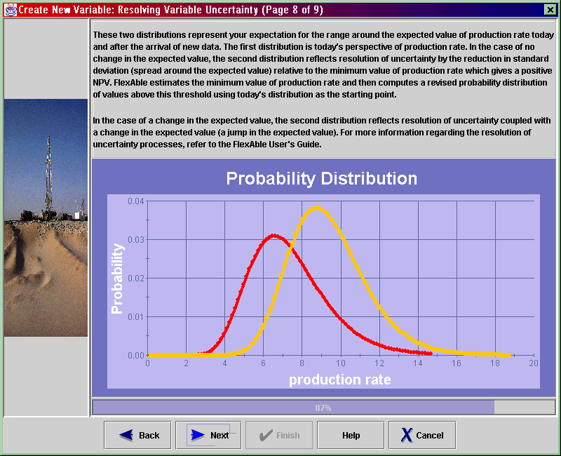

FIGURE 2. Project Experts’ Estimate of Initial Market Size
Before and After Product Development Period.

Typical option analysis uses a value (price) pathway that is continuous. This problem requires a discontinuous path for the value to reflect the stepwise increase in the initial market size. There is no certainty in the magnitude in the initial market size increase. The stepwise change in expected value coupled with reduction in uncertainty around it creates a value pathway reminiscent of diffusion – jump stock price movements modeled by Merton¹. We use the following pricing formula to represent this effect.

$V=\sum_{i=0}^{∞}{\frac{e^{−λt}}{i!}V_{i}}\left(S,X,\text{.}t,r,\sqrt{σ_{\text{combined}}^{2}+δ^{2}(it)}\right)$

$$\begin{aligned}\text{where}: \\ λ={\text{jump}}_{\text{frequency}}; \\ σ_{\text{combined}}^{2}={\text{total}}_{\text{volatility}}\text{;_}\text{and} \\ γ={\text{percentage}}_{{\text{of}}_{{\text{volatility}}_{{\text{due}}_{{\text{to}}_{\text{jump}}}}}}\end{aligned}$$
The probability of a jump occurring is a normally distributed random variable with variance δ² and mean –½δ².

Capturing the Effect of Competitive Entry
In the competitive entry analysis, we follow the solution scheme of Trigeorgis². Incorporating competitive entry requires recasting the option from proprietary to shared. As such, the owner of this shared option has certain expectations regarding when competition may occur and how much of the market will be taken by the competitor. Trigeorgis approach takes into account the following scenarios:

- Decline option and abandon project;
- Buy project now, accepting existing risk:
  - suffer market share loss to competitive entry
  - preempt entry;
- Buy option and wait for information arrival:
  - Buy project when competitor enters, no preemption; accept remaining risk;
  - Buy project at end of option life, if risk reduced; no preemption.

These actions are valued relative to owning a proprietary option on this product, i.e., a 100 percent market share.

Assumptions in the Trigeorgis approach that should be considered include:
- Management’s understands the impact of competitive entry and its timing;
- Project can be scaled down, if competitive entry takes market share.

These assumptions may not always hold.

We test the first assumption’s impact by computing option values for each scenario as a function of time to entry relative to option life and fraction of market lost to competitor. The second assumption will be investment specific. Capital requirements for a manufacturing plant are reasonably linear function of production capacity. However, the cost of laying trans-Atlantic fiberoptic cable, for example, is weak function of data throughput capacity. Thus, the use of this approach should be carefully tested against the investment parameters. For this example, the investment in producing and marketing the product extension can be scaled as a function of the market share available.

$σ_{\text{combined}}=\sqrt{σ_{{\text{simple}}_{\text{diffusion}}}^{2}+σ_{\text{jump}}^{2}(i/t)}$Choice of Option Mathematics
Since the decision to invest can be made at any time during the life of the option, we have chosen an American option approximation. Bjerksund and Stensland published an attractive and readily solveable algorithm. The attractiveness stems from its conceptual use of a trigger value to guide the option owner when to exercise the option before the end of its life. In effect, it computes the value of the asset at which the owner can exercise the option without the potential for remorse. The asset must become so valuable relative to the exercise price that it is unable to decline in value sufficiently before the end of the option life to make the asset’s NPV (=S-X) < 0.

RESULTS
Static DCF Valuation
Whenever a Real Options analysis is performed, a static analysis must be included. The difference between the static DCF and the option valuation is the value of the embedded options. The traditional DCF, using expected values for all variables, comprehends the investor’s perception of project value using available information. It does not, however, incorporate the investor’s ability to defer or even decline participation in a subsequent investment if the newly available information is unfavorable.

The static DCF valuation results are shown in red on Figure 3 as a function of the initial market size. The project NPV has a linear relationship with the market size. This will not be true for critical variable values that cause investment outcomes to cross tax rate boundaries or have non-linear investment-to-revenue relationships. This analysis becomes non-linear at low values of initial market size.

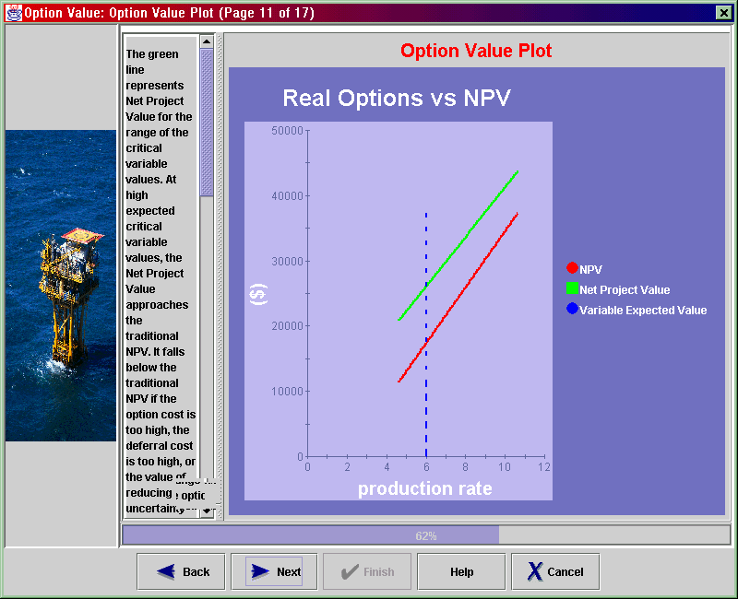

FIGURE 3. NPV of Product Extension
as a Function of Initial Market Size
Real Options Valuation – Proprietary case
The product extension option was first evaluated as a proprietary option. The following table contains the option variable values used in the calculations.

Table 1. Real Options variables
Real Options Model Inputs | Value
S: the present value of the product extension  revenue using EV of initial market size | $36.9 MM
X: the present value of the capital required to  produce the product extension | $20.0 MM
r: company’s cost of capital (WACC) | 15%
t: option life | 1 year
σ: volatility of S due to initial market size  resolution | 265 %
C: cost of the option (cost of development  program) | $2. MM

The volatility of S as a function of initial market size is surprisingly large. Volatilities for equities are typically upper bounded by 70 or 80%. Careful examination of the economic model reveals that a 33% increase in the number of applications per year results in a dramatically improved equipment and manpower utilization. This improved utilization readily translates to the bottom line, given the high profit margin of this product offering. This investment is unusual in its sensitivity to a single variable. One should not expect to see such a large volatility routinely.

The results of the Real Options analysis are shown on Figure 3 in green. The option value is slightly concave with initial market share, as expected. At high values of initial market share, the option value curve approaches the static DCF line. The vertical dashed line in blue indicates the EV of the initial market size at the time management must choose to buy the option, buy the project, or abandon the project outright. This analysis indicates a positive NPV even for the traditional analysis. Because project experts believe the development program will greatly expand the applicability of the product extension, the volatility of the opportunity is quite high. This generates a proprietary Real Option value 75% larger than the static DCF value at today’s expected value of initial market size.

Real Options Valuation – Shared case
Marketing management believes that a competitor may enter the market within the year. The expected market share loss to the competitor’s offering could be as much as 50%. There is not a great deal of certainty around the timing or the loss of market share, so valuing the Shared option should be done with caution. Further, marketing is uncertain regarding their ability to preempt the competitor with an early investment decision.

As the base case valuation for the Shared option, we chose the time to competitive entry as 0.5 years and percent of market share lost as 50%. The four scenarios for action:
- invest now and preempt;
- invest now and still compete;
- invest at 0.5 years and compete; and
- wait to end of option life and invest
are valued as shown below in Figure 4. The proprietary option value is shown for comparison.

Figure 4. Comparison of Action Scenarios for the Shared Option Case.

Clearly, we can equate the first scenario, “Invest now and preempt entry”, with the static DCF valuation. No uncertainty is resolved but the market share is preserved in this scenario.

The second and third scenarios presume the company will introduce the product before uncertainty around its initial market size is clarified. There is some uncertainty resolution in scenario 3 and none in scenario 2. Both of these scenarios assume a 50% loss of initial market share and no scalability to the investment. Consequently, both scenarios 2 and 3 have a value less than scenario 1.

Scenario 4 presumes the company resolves uncertainty as expected, loses 50 percent of the market to the competitor, but can scale the investment to reflect the lowered market share expectation. This scenario really has two variables involved, initial market size and percent market share lost to competitive entry. Comparing scenarios 1 and 4, it is clear that at low initial market size, the project value is more sensitive to capital requirements than uncertainty in initial market size.

Shared Case Sensistivities and Guidance
Concerns around marketing management’s lack of clarity on competitive entry effects were tested by adjusting the timing of the entry and the amount of market lost to the competitor. The amount of uncertainty resolveable during the option life is plotted on the vertical axis of each plot. In Figure 5, we illustrate the preferred management response to a competitive threat as a function of the timing of the entry. This is critical to the project value at competitive entry. It dictates how much uncertainty has been resolved at the time management must decide whether to act or wait until the end of the option life to invest in the production and marketing of the product extension. Only two responses hold a large region on the diagram: “invest now and preempt” and “wait to end of option life and invest”.
Figure 5. Preferred Management Response as a Function of Competitive Entry Timing.

In Figure 6, we illustrate the sensitivity of preferred management response to a competitive threat as a function of the fraction of the market lost to the competitor.
Figure 6. Preferred Management Response as a Function of Market Share lost.

Figure 6 is more interesting than Figure 5, in spite of still being limited to the same two preferred responses. The model indicates that for low market share losses, it is most desirable to wait even if only small amounts of uncertainty are resolveable. As more and more market share is potentially lost, it becomes desirable to exercise early, even at the expense of leaving considerable uncertainty unresolved at the exercise time.

For this investment decision, there were no combinations of competitive effects that encouraged management to invest in the project before or coincident with the competitor’s entry if preemption is not possible.

CONCLUSION
Investments in product extensions when market size is uncertain require caution. In this project, management was unconvinced by the static DCF analysis of the merits of investing in the product extension. Their caution was based on a lack of quantification of the initial market size in an investment whose value is extremely sensitive to the number of applications in the first years. Their inclination was to not pursue the product extension.

Using Real Options, project experts were able to convince management that a small investment to extend the product’s applicability and to promote it to the marketplace would resolve much of the uncertainty around the initial market size. In fact, project experts believed that the market would be larger than presently expected, adding to the value of the product extension. Spending one year and two million dollars to resolve that concern is a valuable purchase when viewed in a Real Options framework. The net option value was nearly nine million dollars greater than the static DCF analysis indicated, even after netting out the option cost of two million and the cost of deferring the positive NPV project for one year.

Contrarians in the organization felt delaying the project would certainly invite competitive entry and probably destroy any value in the project. Application of Trigeorgis’ competitive entry model delivered a thought-provoking action plan for management. Quickly and dynamically, management can evaluate if and when the product extension should be funded.

Merton, R., “Option Pricing When Underlying Stock Returns are Discontinuous,” Journal of Financial Economics, 3 (January-March 1976), 125-144.
Trigeorgis, L., Real Options, Chapter, MIT Press (1997), 274-288.
Bjerksund, P. and Stensland, G., “Closed Form Approximation of American Options,” Scandinavian Journal of Management, 9, 87-99 (1993).

